Bonnington Symbol System
City of Edinburgh Council

Symbol resource 2008

including relevant British Standard symbols from BS 8501

Activities
Catering
College
Environments
Health
Home
People
Self development

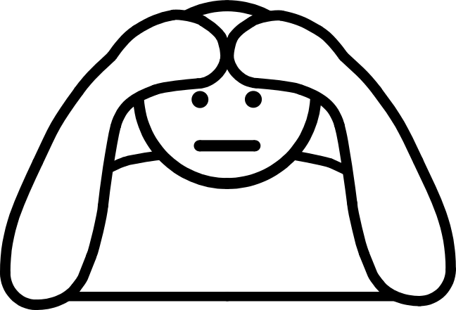

clinics and treatments
mental health
healthcare providers
sexual health





The Resource
This resource has been created as a series of word documents which may be printed out to use as a visual reference and index.

Copy and Paste/Instructions
To reproduce an image:
- Single click on the image ensuring it is selected
- Select Copy from the Edit menu (or use keyboard shortcut Ctrl+C)
- Open the document you wish to place the image in (e.g. word document)
- Select Paste from the Edit menu (or use keyboard shortcut Ctrl+V)

Images may be resized by dragging in or out from a corner, images may be resized up to A4 without any loss of quality.

Images may be placed in tables or text boxes.

If you have any difficulty using any of the images please contact BSS using the contact details below.

Acknowledgement British Standards: Permission to reproduce extracts from the BS 8501:2002 is granted by BSI. The British Standards can be obtained from BSI Customer Services, 389 Chiswick High Road, London W4 4AL. Tel +44 (0)20 8996 9001

Acknowledgement BSS Edinburgh Council: Permission to reproduce BSS symbols is granted by The City of Edinburgh Council Health and Social Care; however reproduction of any part of the CD ROM in any form is not permitted.

Disclaimer: The City of Edinburgh Council cannot accept any responsibility for damage caused to your computer or data whilst using this CD.

Contact information: Gordon Fraser, Performance Review Manager. The City Of Edinburgh, Health and Social Care, Waverley Court, 4 Market Street Tel: +44 (0)131 553 8266
www.edinburgh.gov.uk/internet/social_care/CEC_learning_disability

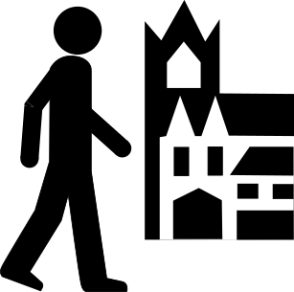 |  | 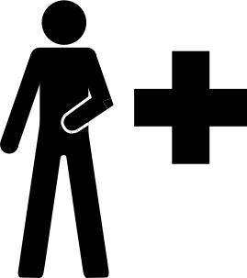
Able to look after self-got out and about  BS 8501 8035 | Able to look after self-food  5250 | Able to look after self-health  5251
 | 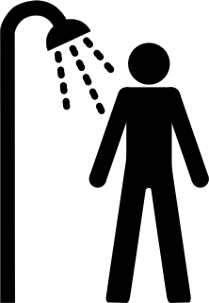 | 
Able to look after self-money  5252 | Able to look after self-shower  5253 | Achieved things  5254
 | 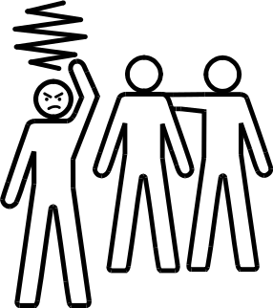 | 
Bottled up angry feelings  5255 | Felt angry and bad tempered  5256 | Felt confused  5257
 |  | 
Felt depressed  5258  Bonnington Symbol System  www.edinburgh.gov.uk | Felt frustrated or upset  5259 | Felt good about self  5260

 |  | 
Felt like crying  5261 | Felt lonely  5262 | Felt people were talking about you  5263
 |  | 
Felt physically unwell  5264 | Felt really good  5265 | Felt sad  5266
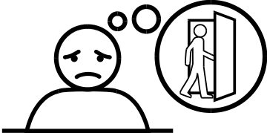 |  | 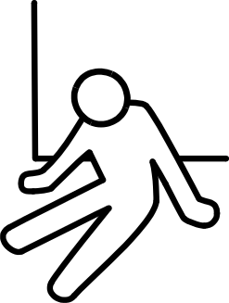
Felt sad about people leaving  5267 | Felt scared  5268 | Felt there was no point  5269
 | 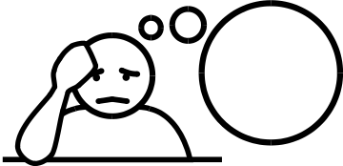 | 
Felt things were too much  5270  Bonnington Symbol System  www.edinburgh.gov.uk | Felt upset by your thoughts  5271 | Felt worried  5272
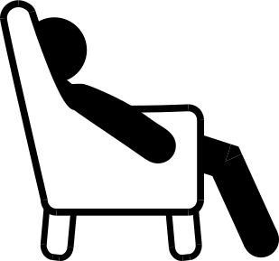 |  | 
Felt you couldn’t be bothered  5273 | Felt you did everything you wanted to  5274 | Felt you got help  5275
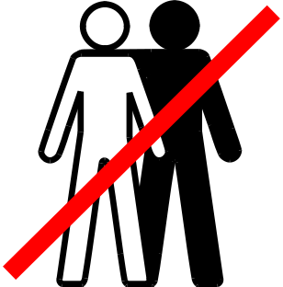 |  | 
Felt you had no friends  5276 | Felt you were being blamed  5277 | Felt you were being picked on  5278
 | 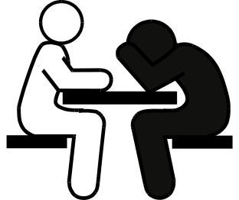 | 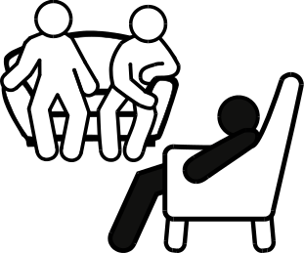
Felt you were to blame  5279 | Found it hard to say how you feel #1  5280 | Found it hard to say how you feel #2  5281
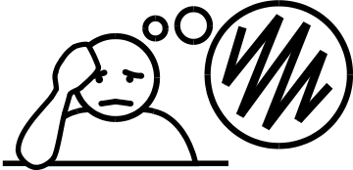   |  | 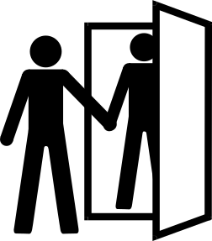
Had bad memories  5282  Bonnington Symbol System  www.edinburgh.gov.uk | Had thoughts about hurting yourself  5283 | Had visitors  5284
 |  | 
Hit someone  5285 | Hurt yourself  5286 | Spoke to others #1  BS 8501 8005
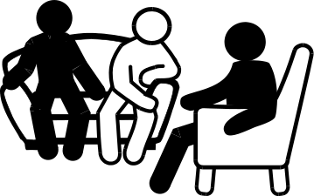 | 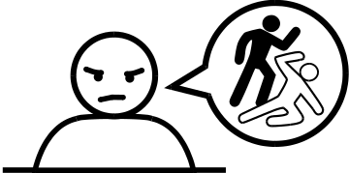 | 
Spoke to others #2  5287 | Talked about hurting others  5288 | Things are good  5289
 |  | 
Things have gone wrong  5290 | Things to look forward to  5291 | Things you need to do  5292
 | 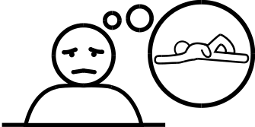 | 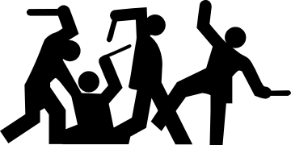
Thought about your problems all the time  5293 | Thought you’d be better dead  5294 | Trouble  5295
Bonnington Symbol System
www.edinburgh.gov.uk

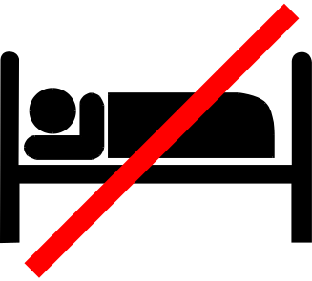
Unable to sleep
5296

Bonnington Symbol System
www.edinburgh.gov.uk

